Create Startup script for an application start and stop

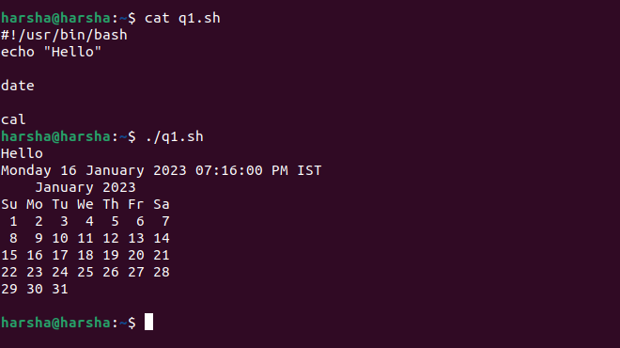

Shell Script to display the number of files in the present working Directory .

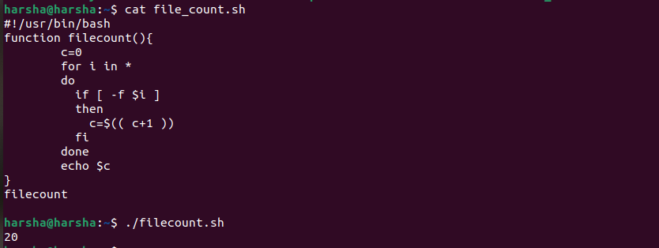

For each directory in a path display number of executable files

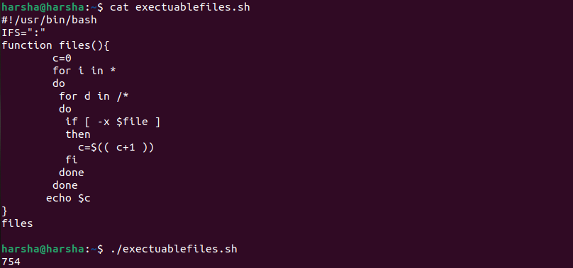

Display the file system which have less than 10% free space available

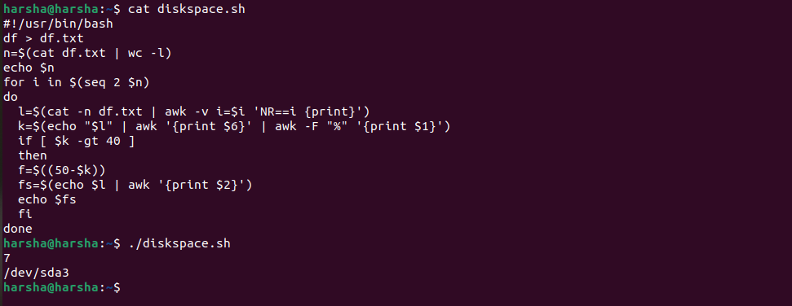

Script that takes any number of directories as command line arguments and list contents of these directories

